Your contact person:

Klaus Müller
Marketing

Head of Communication

Telephone +49 9341 86-1125
Fax +49 9341 86-1411
Klaus.Mueller@weinig.com

April 2018

Date

PRESS RELEASE

The finger-joint expert Weinig Grecon launches a product campaign in the timber construction
An increased performance, more flexibility and an upgraded technology characterise the new generation of the Weinig Grecon compact finger jointing lines. Furthermore, the customer-specific arrangement possibilities are in focus.
Thanks to the PowerJoint range, Weinig Grecon offers an internationally established technology in the construction field. The non-contact glue application and the excellent quality of the fingers are only two benefits amongst many others. The leading expert for finger jointing lines of all performance classes has now gone a step further.
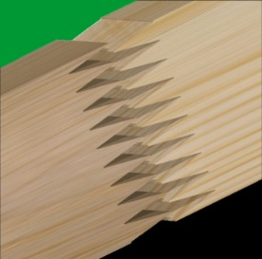
Highly productive top model [picture vertical finger jointing]
The present PowerJoint 15 is complemented by a new top version - 18 cycles are now possible. Starting point of the development
was, as is often the case, a customer requirement. Weinig Grecon
met the demand of the specialist for laminated timber and cross
laminated timber not only in terms of speed, but also improved its application technology. With the new system it is now possible to process even shorter timber pieces. For the customer this meant an input length of 550 mm. A pre-alignment, a special tandem clamping station and the pre-infeed system provide for an optimal position of the wood and facilitate the high cycle output. With the automatic feeding and the automatic emptying, an easy production with order picking is possible.

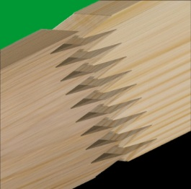
Innovation for the entire product line [picture
vertical finger jointing]
Also the decentralised compact system presently known as CF was revised and optimised. The new model PowerJoint 12 now makes 12 cycles poss
ble (increase of 20 %). But the technicians provided also other improvements to the finger jointing line used for construction timber. Thus, larger cross sections can now be processed in less time. Furthermore, the clamping patterns of the shaper and the press are identical. The result is an absolutely offset-free product.

The new PowerJoint 8 horizontal [picture vertical finger jointing]

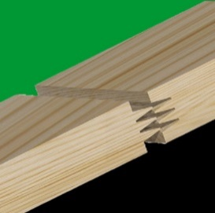
With the PowerJoint 8 Weinig Grecon has already had the quickest system for the compact construction style (shaping / gluing / pressing in one clamping position) for vertical finger joints. Timber pieces of a maximum width of 300 mm
can be processed by the system with up to 8 cycles per minute. The newly developed Power Joint 8 H is the first decentralised compact finger jointing line for horizontal finger joints which can be equipped with scoring units. A highly attractive feature of the PowerJoint 8 H is the possibility to operate the system with all three conventional gluing systems, i. e. a glue comb, the roller system and the non-contact glue application. Customers from Austria, Germany and Scandinavia have already expressed their interest in the new generation of the PowerJoint 8 H. The system will be used above all for the log house construction, for the production of CLT or for window scantlings in the future.

Open to the different needs of the customers
Several tailored arrangement versions are possible for all three machine models. Weinig Grecon meets the increasing demand for customer-specific system concepts. "We are well known for our ability to quickly identify new market needs and specifically implement the customers' requests by highly efficient technology on the market", project manager Frank Medicus emphasises.

Ready for the production of the future [picture 4.0]
"We are well positioned for digitisation and as technology partner we support our customers on their way with solutions that are exactly matched to the needs", product manager Dirk Bartens says. The software module ProLam for construction timber systems offers another possibility for the linked production. This lamella production computer is designed to control the production orders through the finger jointing line and is available in three different configurations. The reliable ProLam saves time and creates the conditions for a comfortable data exchange with other system components.

Other special features are the innovative operator control by touch screen, the IO link and a comprehensive sensor technology which ranges from the alarm functions to the production control with evaluation and analysis.

All PowerJoint models are equipped with an automatic dimension adjustment and provided with a distance and time optimised infeed into the press.

5 pictures

